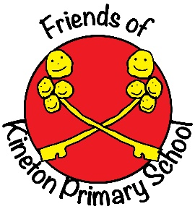

# The Friends of Kineton Primary School

**Charity Registered Number: 1062157**

**Year 2023-2024**

We started the year with committee funds of £9,349

Income for the year was £14,472 Expenditure was £ 9,900

Surplus of 4,572

Income came from Bonfire Night, Victorian Evening, Scalextric night, Summer family BBQ, Sports Day, Wreath making event, and the usual Film nights and Discos and Wellesbourne Lions Santa Sleigh £300.

We received a grant of £500 through the Charities Trust.

Donations came from Kineton United charities, the local Art Group and the local community.

These were transferred to school to be used for art projects and new books for the library

Expenditure included Bouncy castle for the Summer BBQ at school, funding the Christingle and a donation to the year 6 leavers party.

We ended the year with committee funds of £9349

I have always enjoyed being treasure but its now time to step down and hand over to someone else.

Janet Lee, Treasurer,14th **November 2024**